SolarSize – Solar Estimation Model Initial Testing

Our solar estimation model uses all sky global irradiance values from the NASA Power API along with dew points, temperatures, pressure at surface, and solar zenith angles to calculate the direct normal irradiance and direct horizontal irradiance on a solar panel at the given location. This is achieved through converted global horizontal irradiance values from the API call to direct horizontal and direct normal (DNI and DHI) values using equations and the DIRINT model (will add more information and sources later).

DNI and DHI values are then used in conjunction with specifications of the solar panels given by user inputs (panel efficiency, panel location and direction, overall system efficiency, number of panels) to calculate the expected output in KWH in hourly intervals for the desired data range. As of now, the NASA API has data available from mid 2021 and earlier.

**Testing**

In order to test our model, we were given data from GreenWave Innovations of a business location that has an installation of 89.7 kW comprising of 260 solar panels. These panels were REC 345-Watt panels, with an area of 2.005m^2, panel efficiency of 17.2%, and an estimated system efficiency of 80-85% (meaning 20% system loss due to inverters, dust, reflected light, heat, etc.).

We inputted these values into our model/website, see image on next page. These values are used to estimate the production using the methodology outlined above. Our goal with the model is to predict within 10% overall production YoY and 5% of peak production.

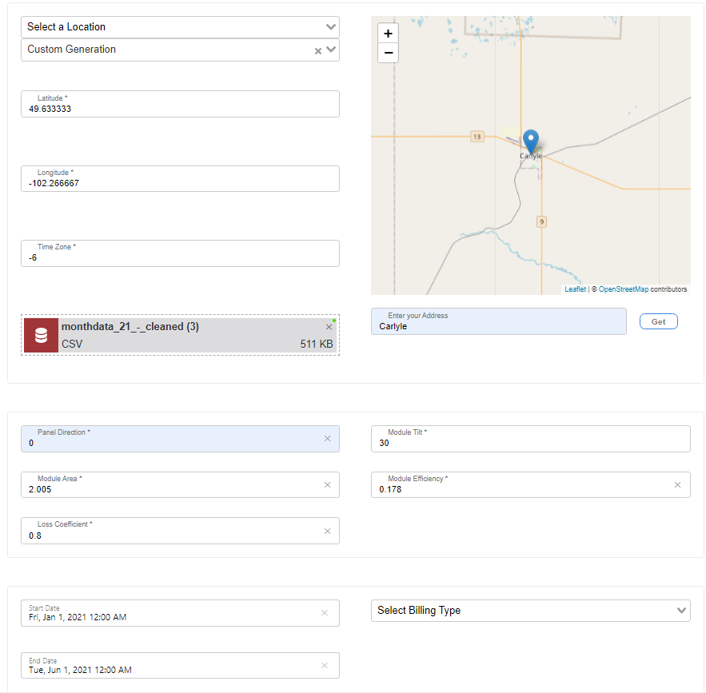

Inputs used on the website to calculate the solar output vs production

**Outputs – Black = Estimation Model, Blue = Real Production Data**

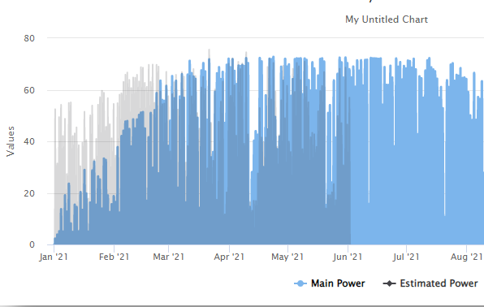

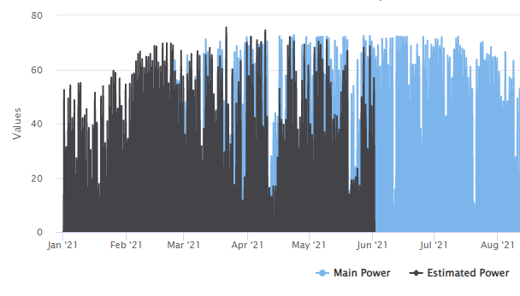

By analysing this chart, we can see that the model is accurate within 5% of peak production, with a maximum value of 75KwH compared to a real value of 72.5 kwH. This is good as it does not overestimate how much the system will produce.

By looking at the winter months, we can see how much production is lost due to snow and ice coverage in the real data. While it is often not worth it to clean snow off of panels due to man hours costing more than the power saved, this demonstrates the real effects of snow being on the panels.

Lastly, we can see that the model sometimes underfits with how much power is produced, this can be attributed to the fact that the NASA API data is at a resolution of 10km and their methodology of producing GHI values may be overly aggressive when it comes to cloud cover.